Project Design Phase-II

Data Flow Diagram & User Stories

|  |  |
| --- | --- |
| Date | 2 July 2025 |
| Team ID | LTVIP2025TMID21215 |
| Project Name | ToyCraft Tales: Tableau's Vision into Toy Manufacturer Data |
| Maximum Marks | 5 |

# Data Flow Diagrams:

A Data Flow Diagram (DFD) is a traditional visual representation of the information flows within a system. A neat and clear DFD can depict the right amount of the system requirement graphically. It shows how data enters and leaves the system, what changes the information, and where data is stored.

# Example: [(Simplified)](https://developer.ibm.com/patterns/visualize-unstructured-text/)

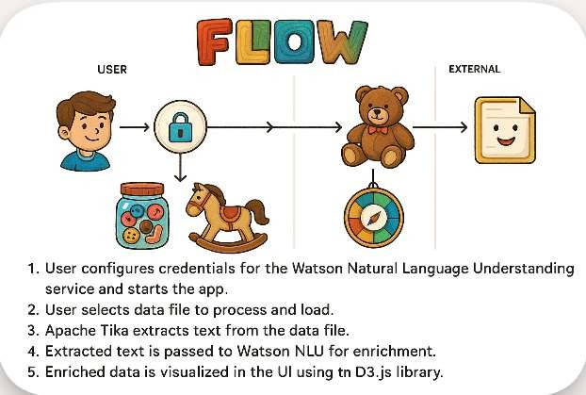

**User Stories**

Use the below template to list all the user stories for the product.

|  |  |  |  |  |  |  |
| --- | --- | --- | --- | --- | --- | --- |
| **User Type** | **Functional Requirement (Epic)** | **User Story Number** | **User Story / Task** | **Acceptance Criteria** | **Priority** | **Release** |
| **Customer (Mobile User)** | Registration | USN-1 | As a user, I can register using my email, password, and confirm password. | I can access my ToyCraft account/dashboard. | High | Sprint-1 |
|  |  | USN-2 | As a user, I receive a confirmation email upon registration. | I receive an email and click confirm. | High | Sprint-1 |
|  |  | USN-3 | As a user, I can register using Facebook. | I can log in and access dashboard via Facebook. | Low | Sprint-2 |
|  |  | USN-4 | As a user, I can register using Gmail. | I can log in using my Gmail account. | Medium | Sprint-1 |
|  | Login | USN-5 | As a user, I can log in using my email and password. | I can access dashboard after login. | High | Sprint-1 |
|  | Dashboard | USN-6 | As a user, I can view toy category performance, sales, and trends on a  dashboard. | Dashboard shows charts, category performance, and  price distribution. | High | Sprint-2 |
|  | Charging Station Map | USN-7 | As a user, I can view nearby toy stores or retail sales regions on a map. | The map updates based on location. | Medium | Sprint-2 |
| **Customer (Web User)** | EV Analytics Dashboard | USN-8 | As a web user, I can compare toy brands by category, pricing, and sales using graphs. | I see graphs like bar, bubble, and treemap. | High | Sprint-2 |
|  | Interactive Filters | USN-9 | As a web user, I can filter data by region, toy type, or brand. | Filters apply instantly and update charts. | High | Sprint-2 |
|  | Download Reports | USN-10 | As a web user, I can export dashboards as PDF reports. | PDF is downloaded and well  formatted. | PDF is downloaded and formatted well. | Medium | Sprint-3 |
| **Customer Care Executive** | Support View | USN-11 | As a support agent, I can view queries or feedback on product sales or dashboard usage. | Ticket system or feedback log is visible. | Medium | Sprint-3 |

|  |  |  |  |  |  |  |
| --- | --- | --- | --- | --- | --- | --- |
|  | Update Info | USN-12 | As a support agent, I can request updates to toy product data. | Request is sent to admin. | Low | Sprint-3 |